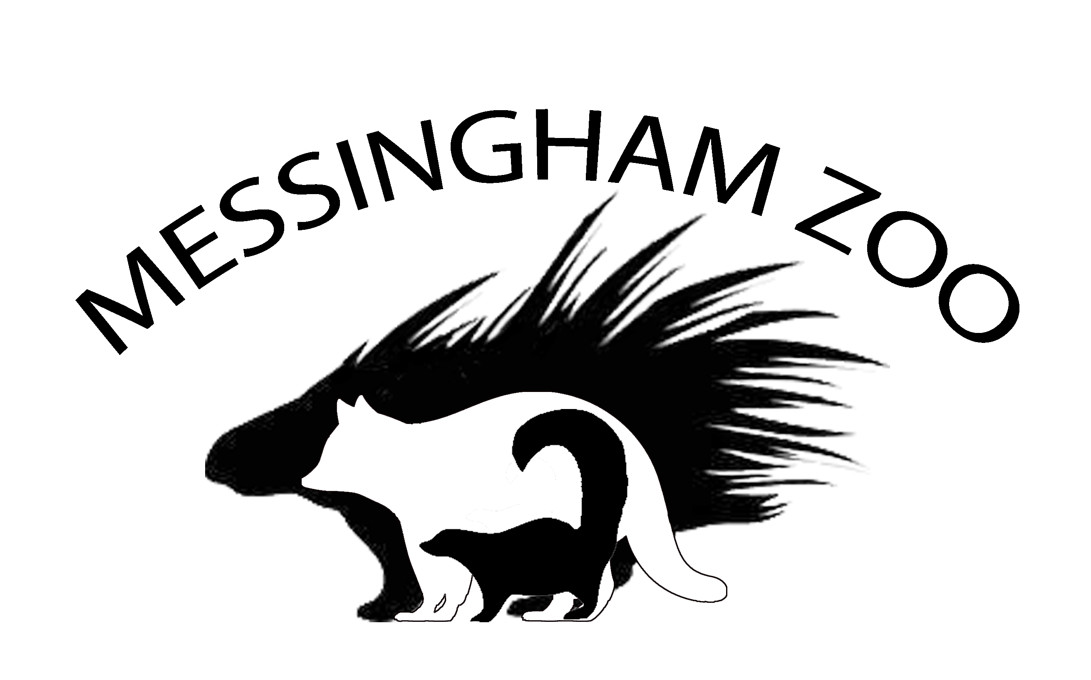

Animal questionnaire

- Which was your favourite animal and why?
………………………………………………………………………………………………………………………………………………………………………………………………………………………………………………………………………………………………………………………………………………………………………………………………

- The best pattern was on the ……………………………………………………………………………..
- The best smell I remember was ………………………………………………………………………..
- What other small animals would you like us to get for Messingham zoo in the future?
……………………………………………………………………………………………………………………………….
Any other comments .........................................................................................................................................................................................................................................................................................................................................................................................................................................................................................................................................................................................................................................................................................

Thank you for visiting Messingham zoo.
We hope you had a great day-Please visit us again.

